Activity 4.1: Dr Snow's cholera map
Here is a copy of Dr John Snow's map of the cholera outbreak that took place in Soho in 1854.

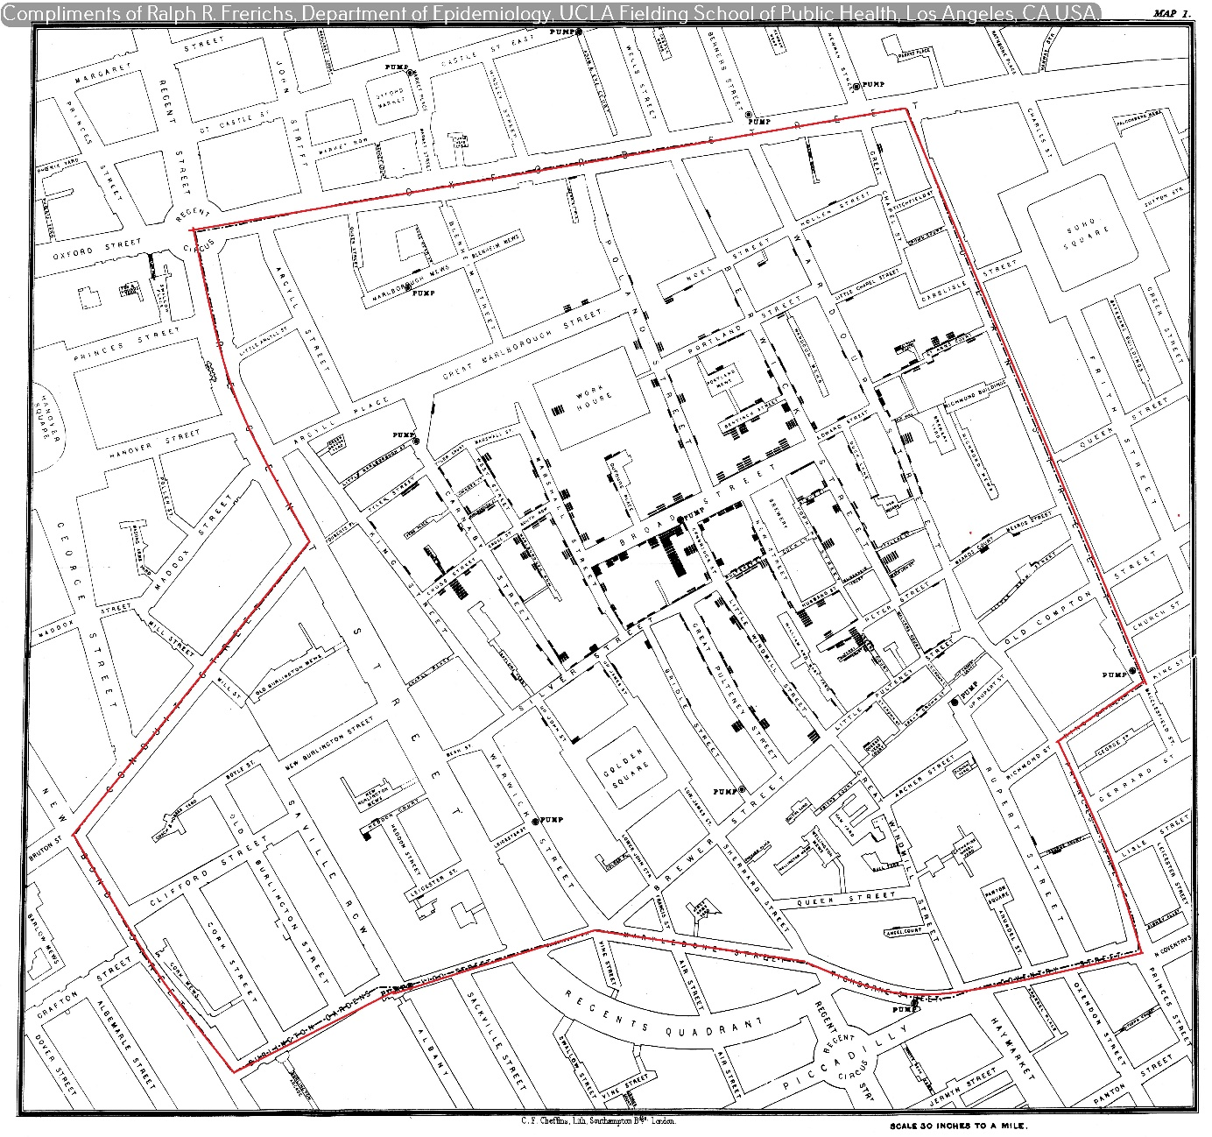

You can also use Handout 4.1 or find a clearer version of the map here: https://www.merrittcartographic.co.uk/cholera.html.
Study your copy of Dr Snow's map and carry out two important stages of computational thinking.

Decomposition and data collection
- How many drinking water pumps are there in Soho?
- Where are the pumps located? Mark each pump with a blue circle on your map.
- Add up the number of cholera deaths in each street and record the number of deaths for each street on your map. Remember, each bar on the map represents a person who died of cholera.

Pattern recognition
- Colour in the streets where:
a. more than 20 people died in red
b. between 16 and 19 people died in orange
c. between 10 and 15 people died in yellow
d. between 3 and 9 people died in blue
e. fewer than 3 people died in green.
Once the data has been processed it is easier to see patterns.

Look at the data you have processed; look at your annotated map and draw your own conclusions.
- Explain what you think caused the Soho cholera outbreak.

- Explain why Dr Snow’s map shows no deaths at the brewery and only five deaths at the workhouse even though 535 people lived there.

- What would you do to put a stop to the cholera outbreak?

